# Merge conflicts

## INTERMEDIATE GIT

## George Boorman

Curriculum Manager, DataCamp

## Conflicts

Conflict

Inability to resolve differences in the contents of one or more files between branches

Edit the same file in two branches

Try to merge

Git doesn't know what version to keep Conflict!

## Conflicting versions of README.md

documentat~~i~~on **branch**

ma

~~i~~

n

**branch**

# Contents and usage

This repo contains source code

for the DataCamp website.

It is for internal use only,

external access is prohibited.

# Contents and usage

This repo contains source code for the DataCamp website.

It also contains source code for an AI-Assistant (recommendation system) that takes prompts from learners and returns suggested content that they might be interested in.

It is for internal use only, external access is prohibited.

## Merging

From the

main

branch

git merge documentation

Auto-merging README.md

CONFLICT (add/add): Merge conflict in README.md

Automatic merge failed; fix conflicts and then commit the result.

## Opening the file

nano README.md

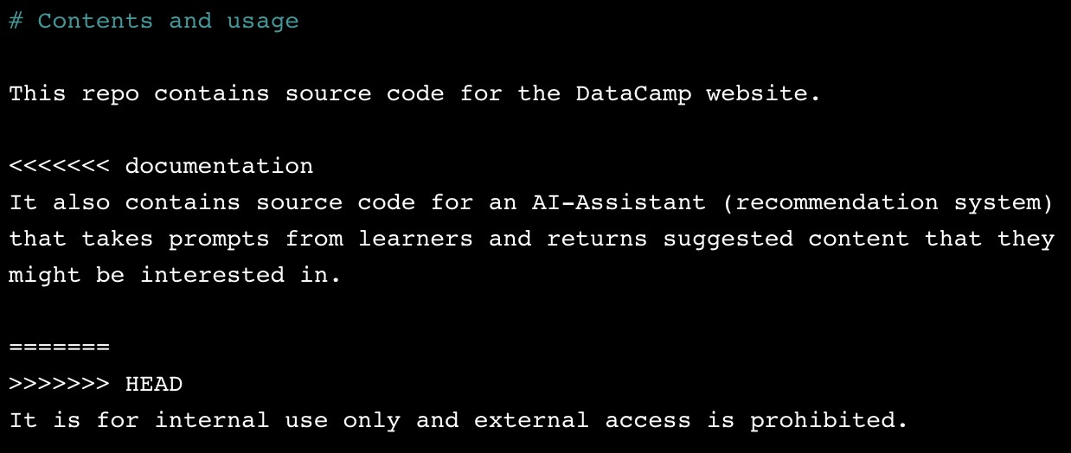

## Git conflict syntax

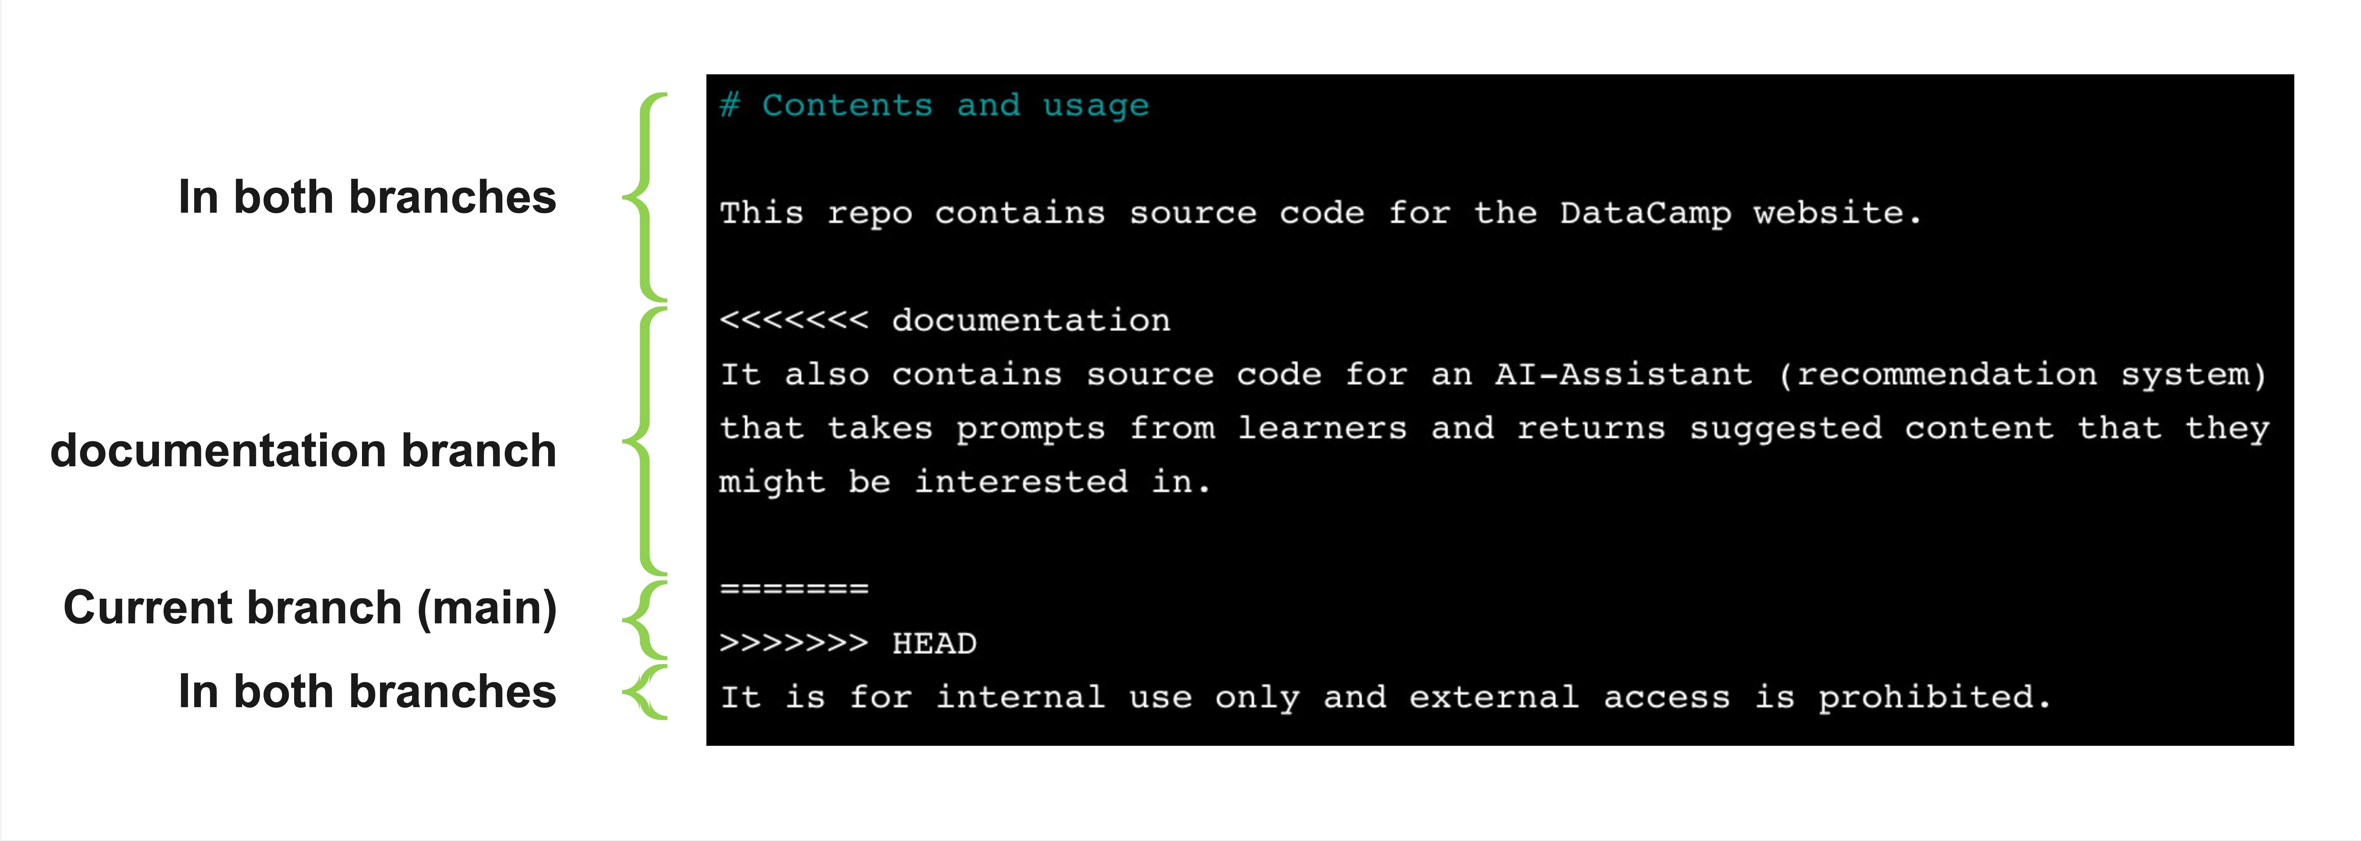

## Resolving the conflict

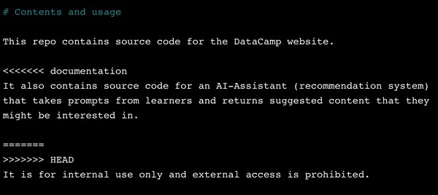

Save:

Ctrl + O

, then

Enter

Exit: Ctrl + X

## Merging the branches

Merging now that the conflict is resolved

git add todo.txt

git commit -m "Resolving todo.txt conflict"

git merge documentation

Already up to date.

Prevention is better than cure!

**Let's practice!**

**INTERMEDIATE GIT**

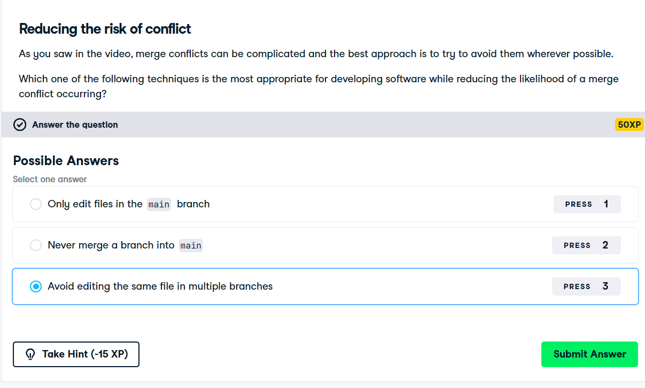

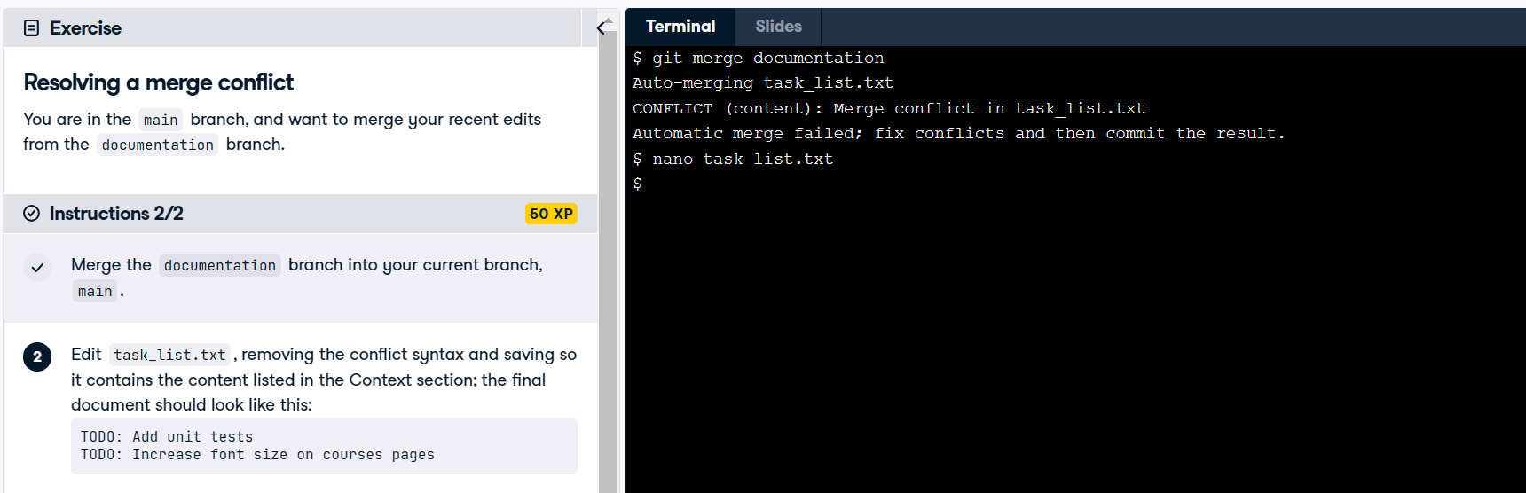

Open task_list.txt file by nano command

This editor will open

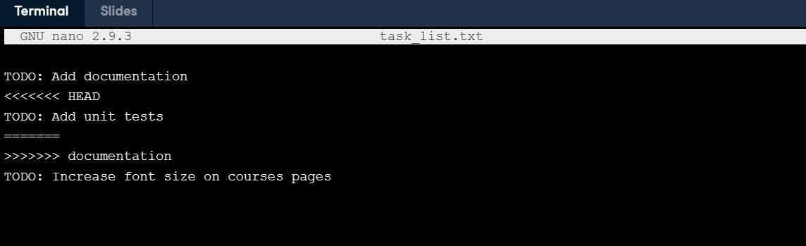

Then remove the conflict

Remove 1, 2, 4, and 5 lines. After removing the file is looks like this.

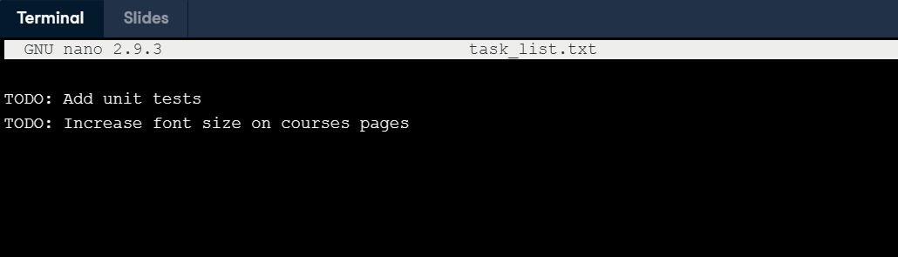

**Introduction to remotes**

**INTERMEDIATE GIT**

### George Boorman

Curriculum Manager, DataCamp

## Local repo



## Remote repo

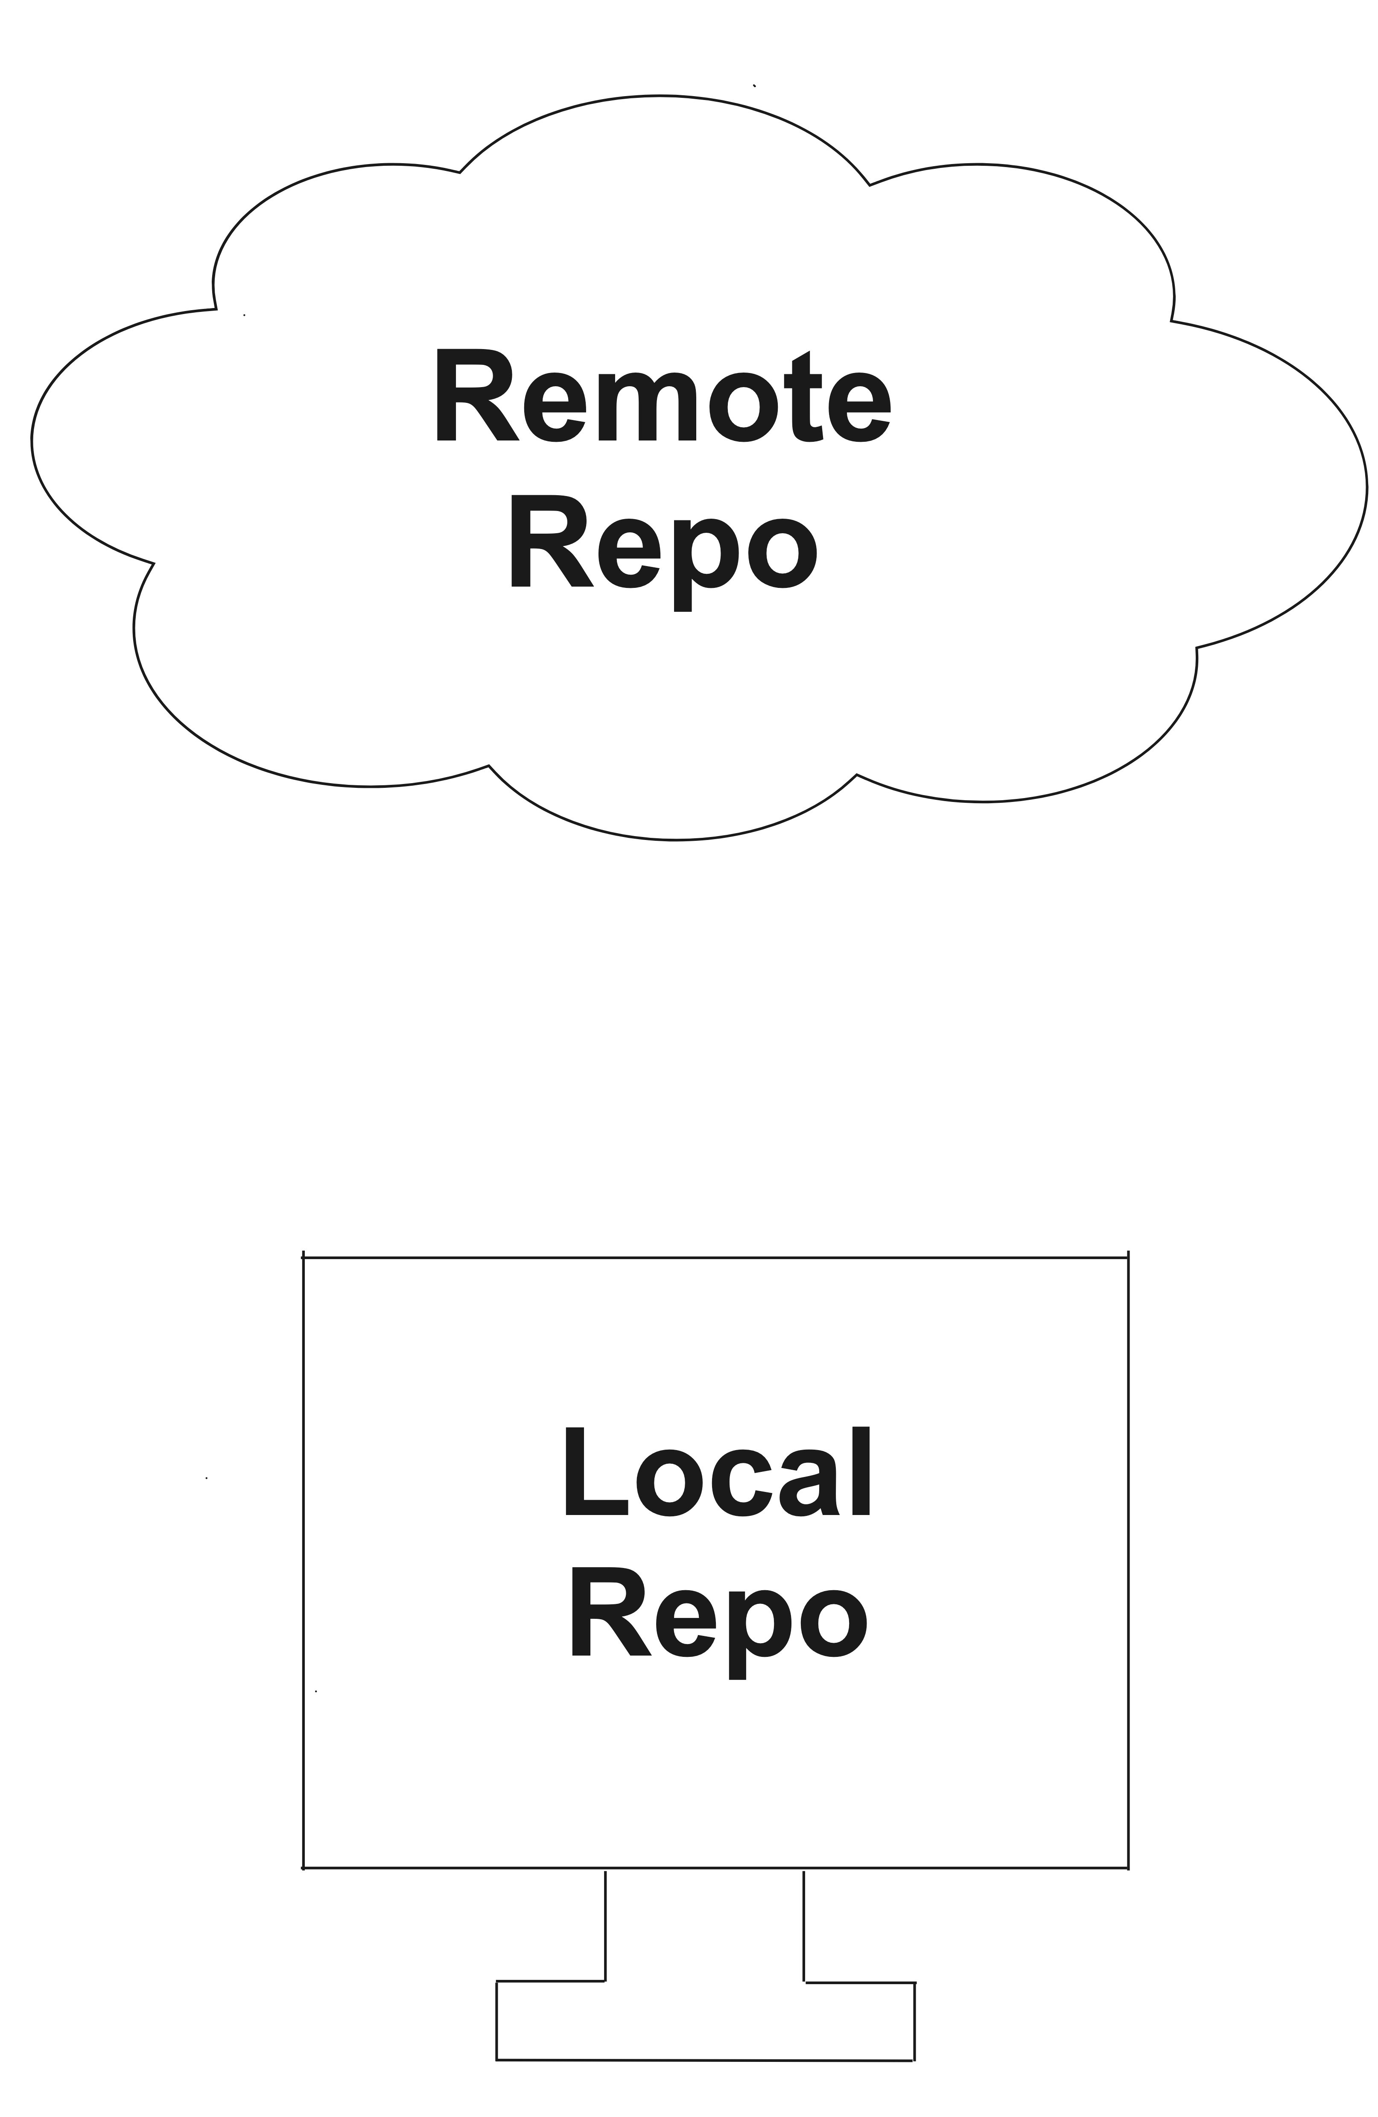

**Why use remote repos?**

**Benefits of remote repos**  Everything is backed up

Collaboration, regardless of location

## Cloning a repo

Cloning and naming a local project

git clone /home/george/repo new_repo

Repo copies on our local computer = local remotes

Making copies = cloning

git clone path-to-project-repo

Cloning a local project

git clone /home/george/repo

## Cloning a remote

Remote repos are generally stored in an online hosting service

git clone https://github.com/datacamp/project

e.g., GitHub, Bitbucket, or GitLab If we have an account:

We can clone a remote repo on to our local computer

git clone URL

## Identifying a remote

When cloning a repo

Git remembers where the original was

datacamp

Git stores a remote **tag** in the new repo's configuration

List all remotes associated with the repo

git remote

## Getting more information

Get more information about the remote(s)

git remote -v

datacamp https://github.com/datacamp/project (fetch) datacamp https://github.com/datacamp/project (pull)

## Creating a remote

When cloning, Git will automatically name the remote

origin

git remote add name URL

Create a remote called

george

git remote add george https://github.com/george_datacamp/repo

Defining remote names is useful for merging

**Let's practice!**

**INTERMEDIATE GIT**

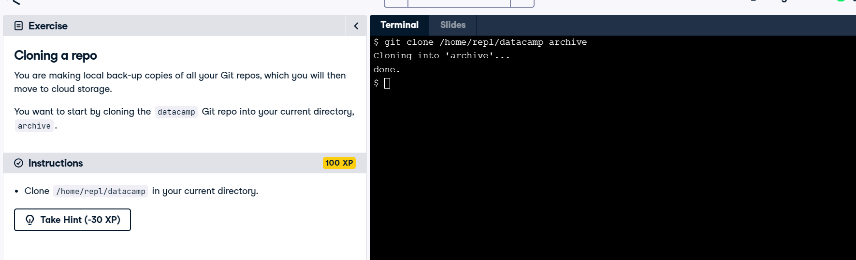

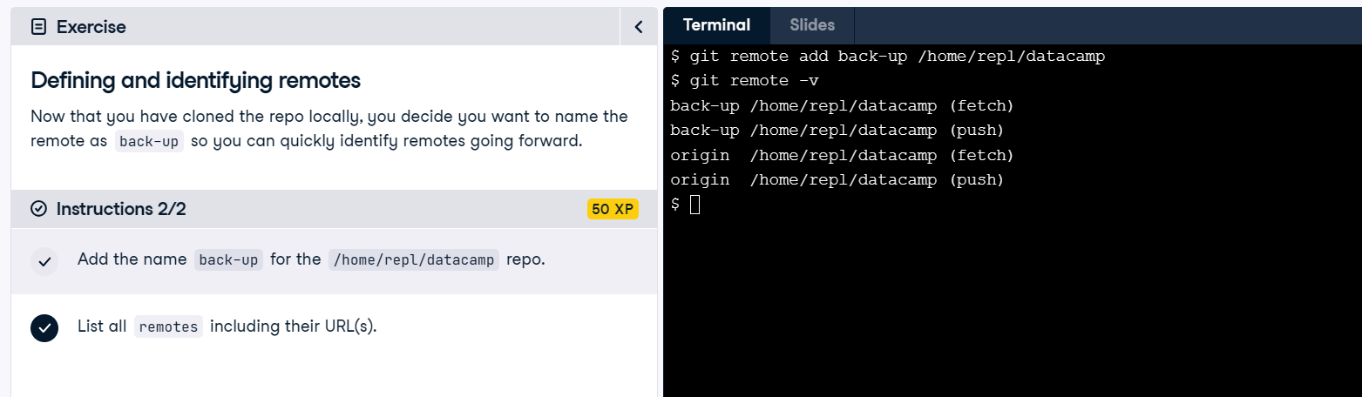

# Pulling from remotes

## INTERMEDIATE GIT

## George Boorman

Curriculum Manager, DataCamp

## Remote vs. local

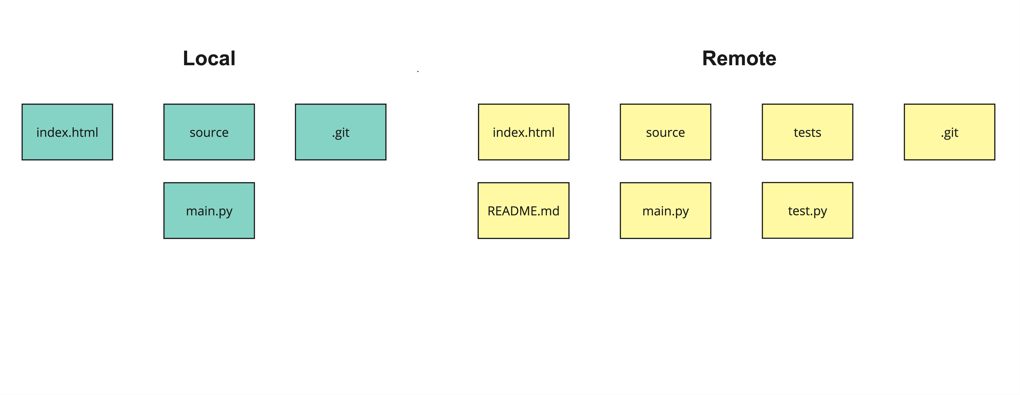

## Collaborating on Git projects

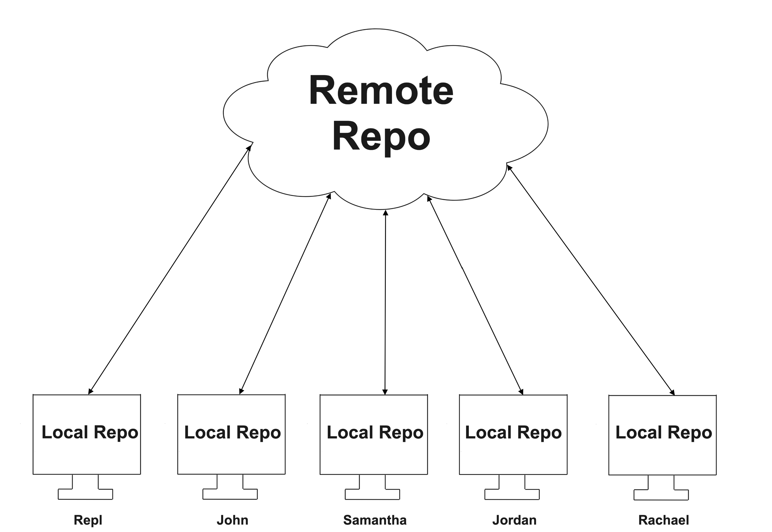

## Fetching from a remote

Fetch from the origin remote

git fetch origin

Fetch all remote branches

Might create new local branches if they only existed in the remote

Doesn't merge the remote's contents into local repo

## Fetching a remote branch

Fetch only from the origin remote's main branch

git fetch origin main

From https://github.com/datacamp/project

* branch main -> FETCH_HEAD

## Synchronizing content

Merge

origin

remote's default branch (

main

)

into the local repo's current branch

git merge origin

Updating 9dcf4e5..887da2d

Fast-forward

tests/tests.py | 13 +++++++++++++

README.md | 10 ++++++++++

2 files changed, 23 insertions (+)

## Pulling from a remote

Local and remote synchronization is a common workflow Git simplifies this process for us!

Fetch and merge from the remote's default (

main

)

into the local repo's current branch

git pull origin

## Pulling a remote branch

Pull from the origin remote's dev branch

git pull origin dev

Still merges into the local branch we are located in!

## Git pull output

From https://github.com/datacamp/project

* branch dev -> FETCH_HEAD

Updating 9dcf4e5..887da2d

Fast-forward

tests/tests.py | 13 +++++++++++++

README.md | 10 ++++++++++

2 files changed, 23 insertions (+)

## A word of caution

git pull origin

Updating 9dcf4e5..887da2d

error: Your local changes to the following files would be overwritten by merge:

README.md

Please commit your changes or stash them before you merge.

Aborting

Important to save locally before pulling from a

remote

**Let's practice!**

**INTERMEDIATE GIT**

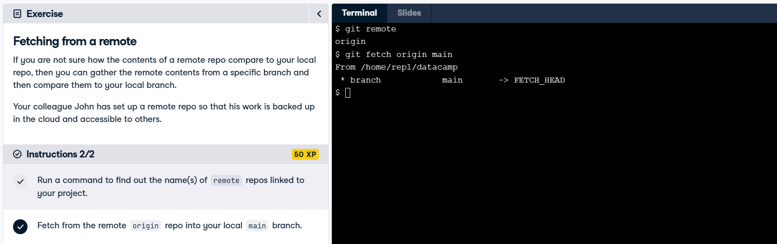

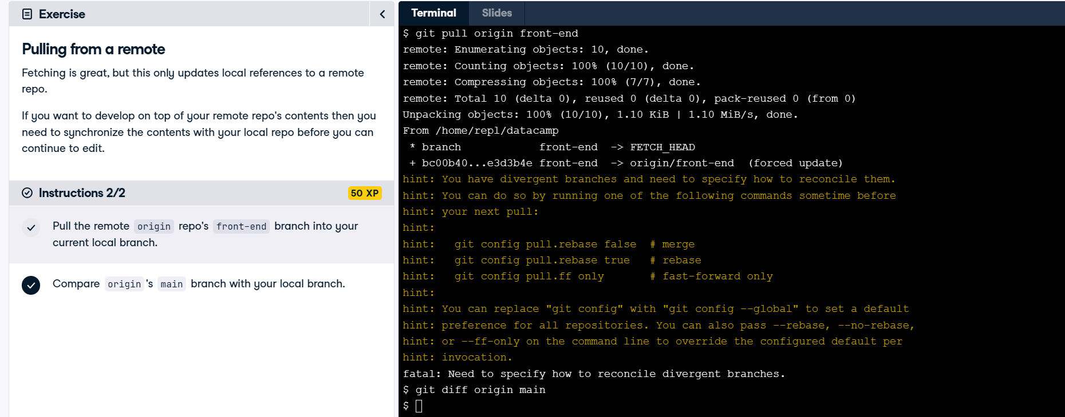

# Pushing to remotes

## INTERMEDIATE GIT

## George Boorman

Curriculum Manager, DataCamp

## Pulling from a remote

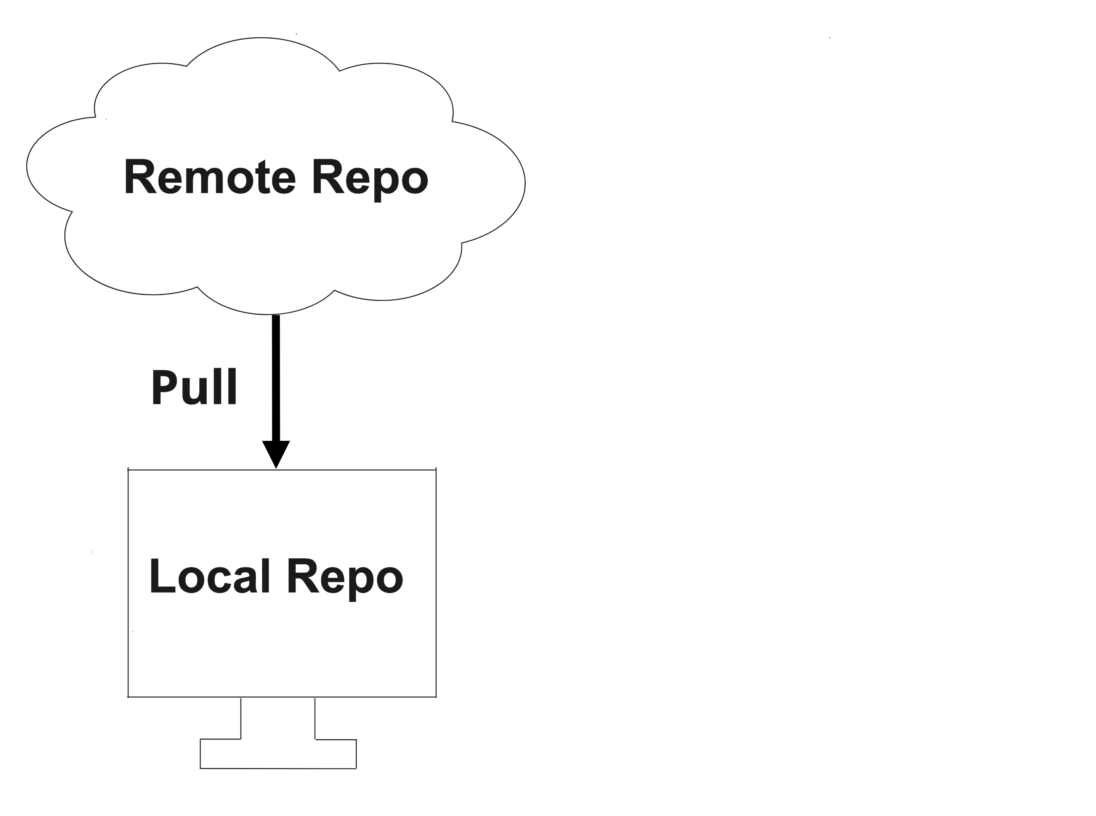

## Pushing to a remote

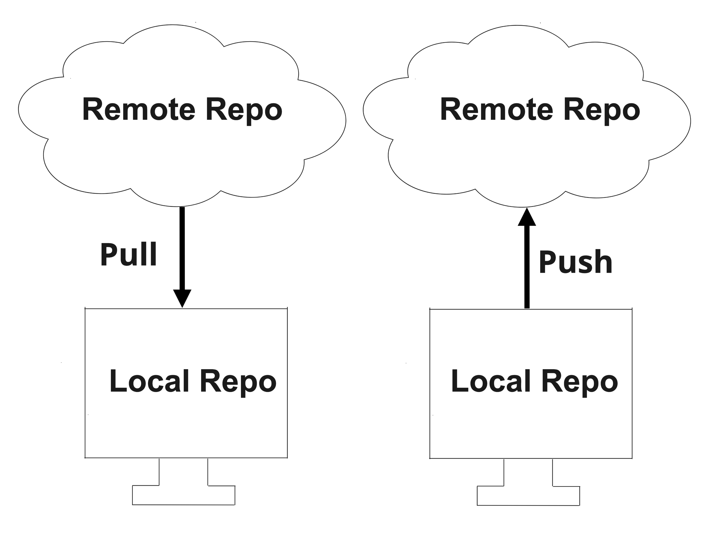

## git push

Save changes locally first!

git push remote local_branch

Push

i

n

t

o

remote

**from**

local_branch

Push changes into

origin

from the local repo's

main

branch

git push origin main

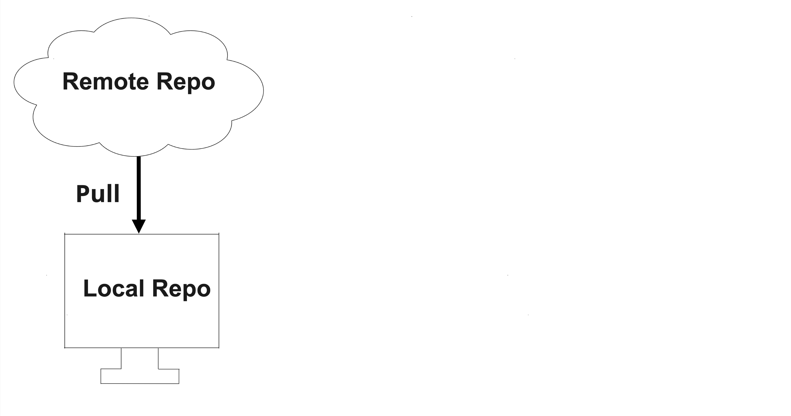

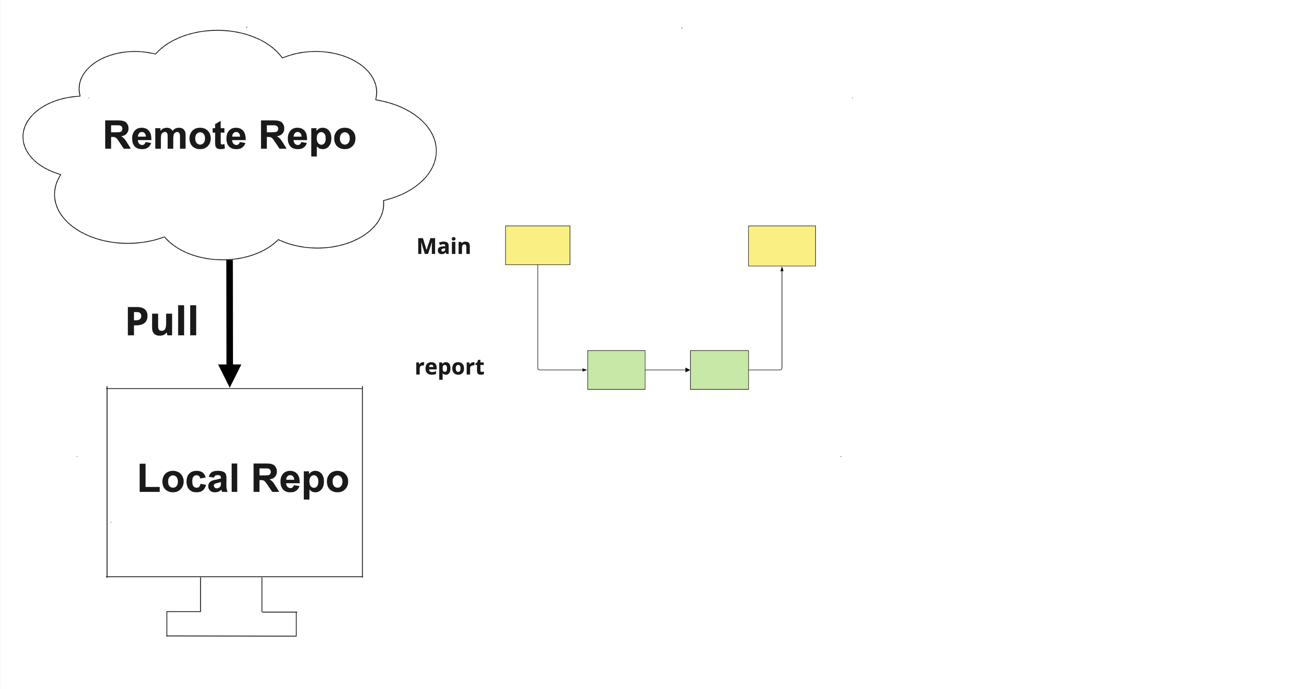

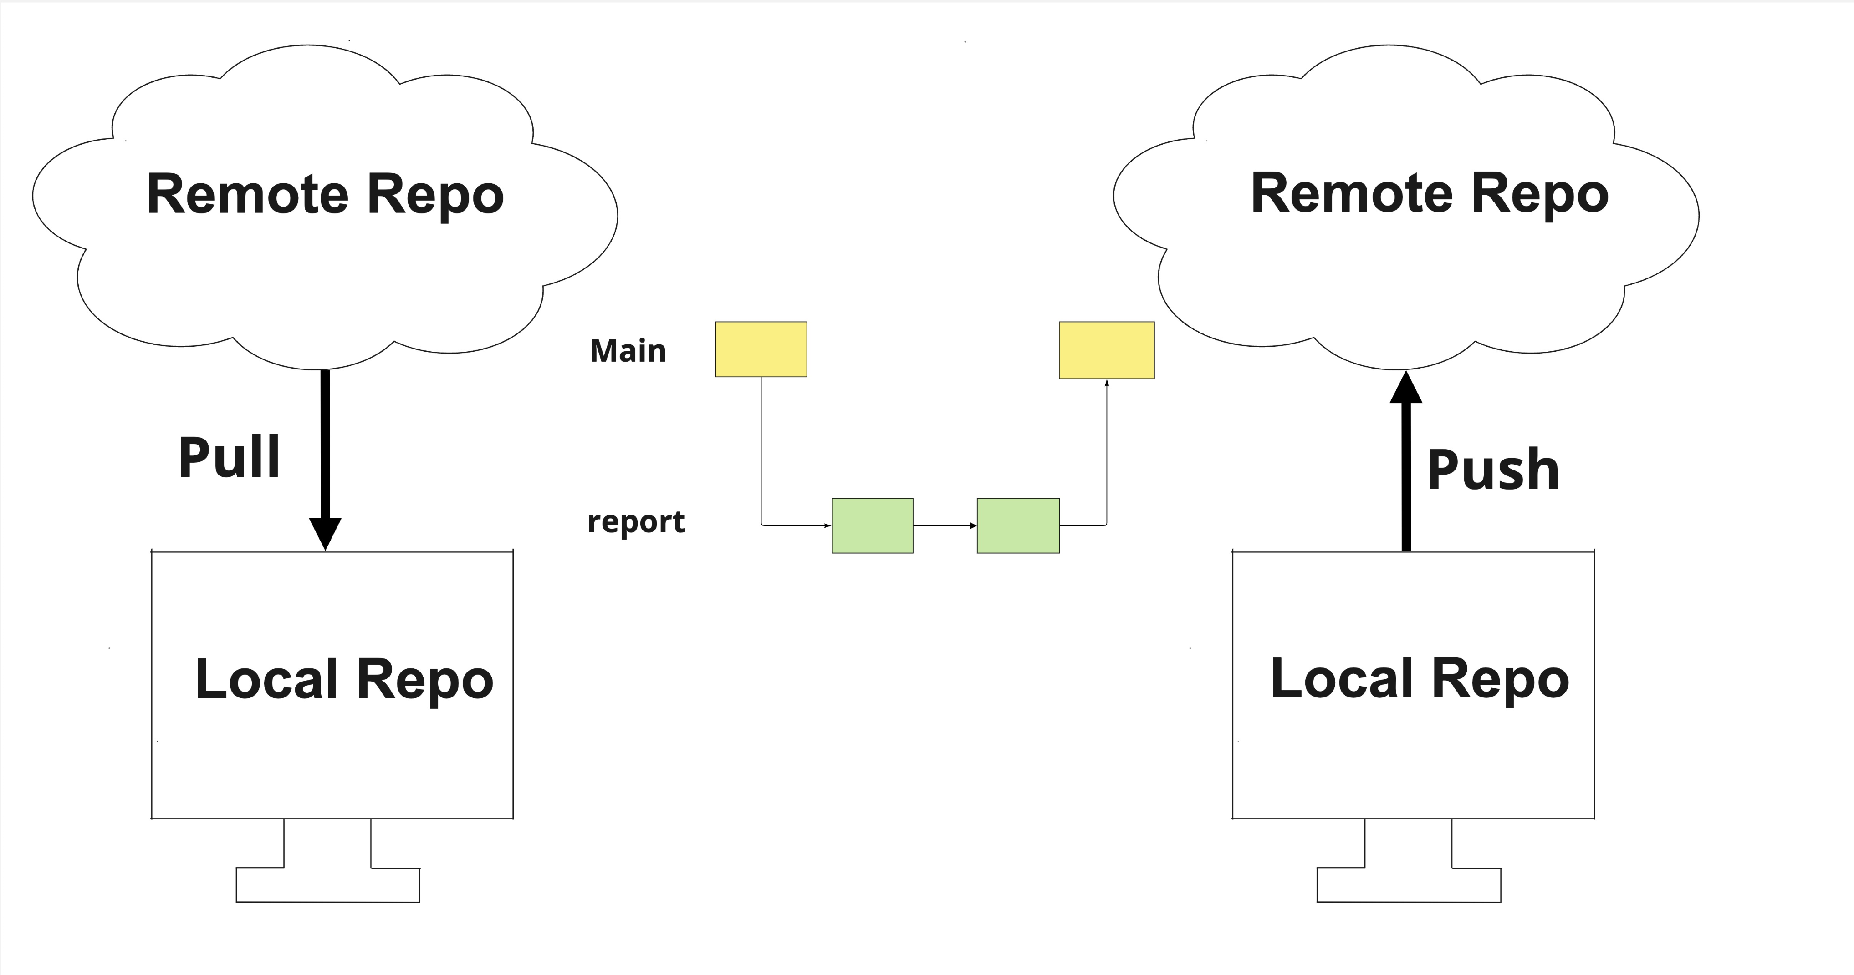

## Pushing first

Pushing

main

to the remote before pulling

git push origin main

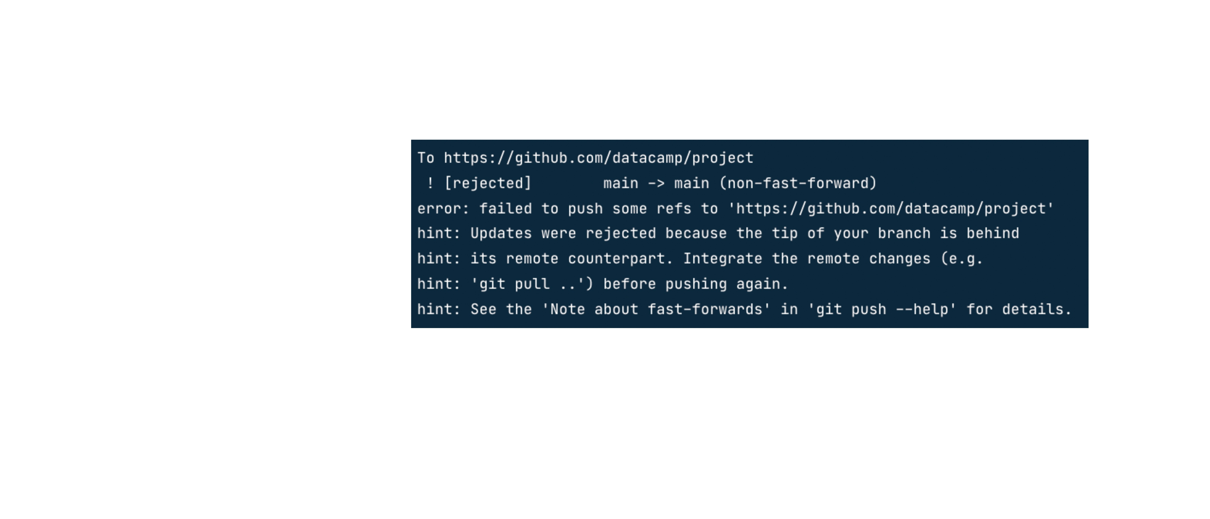

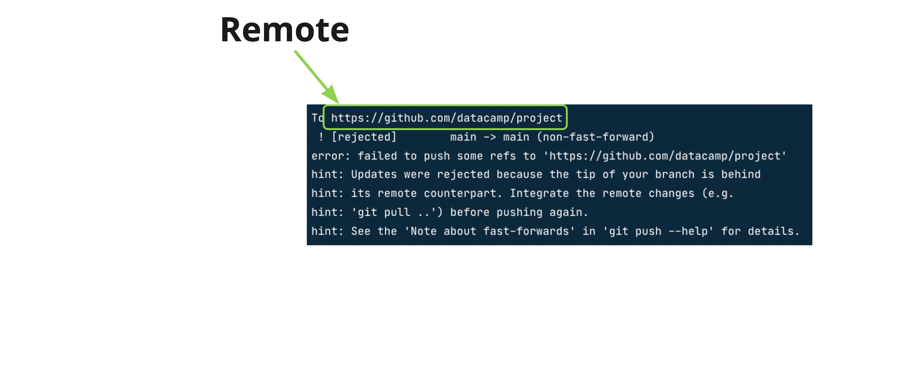

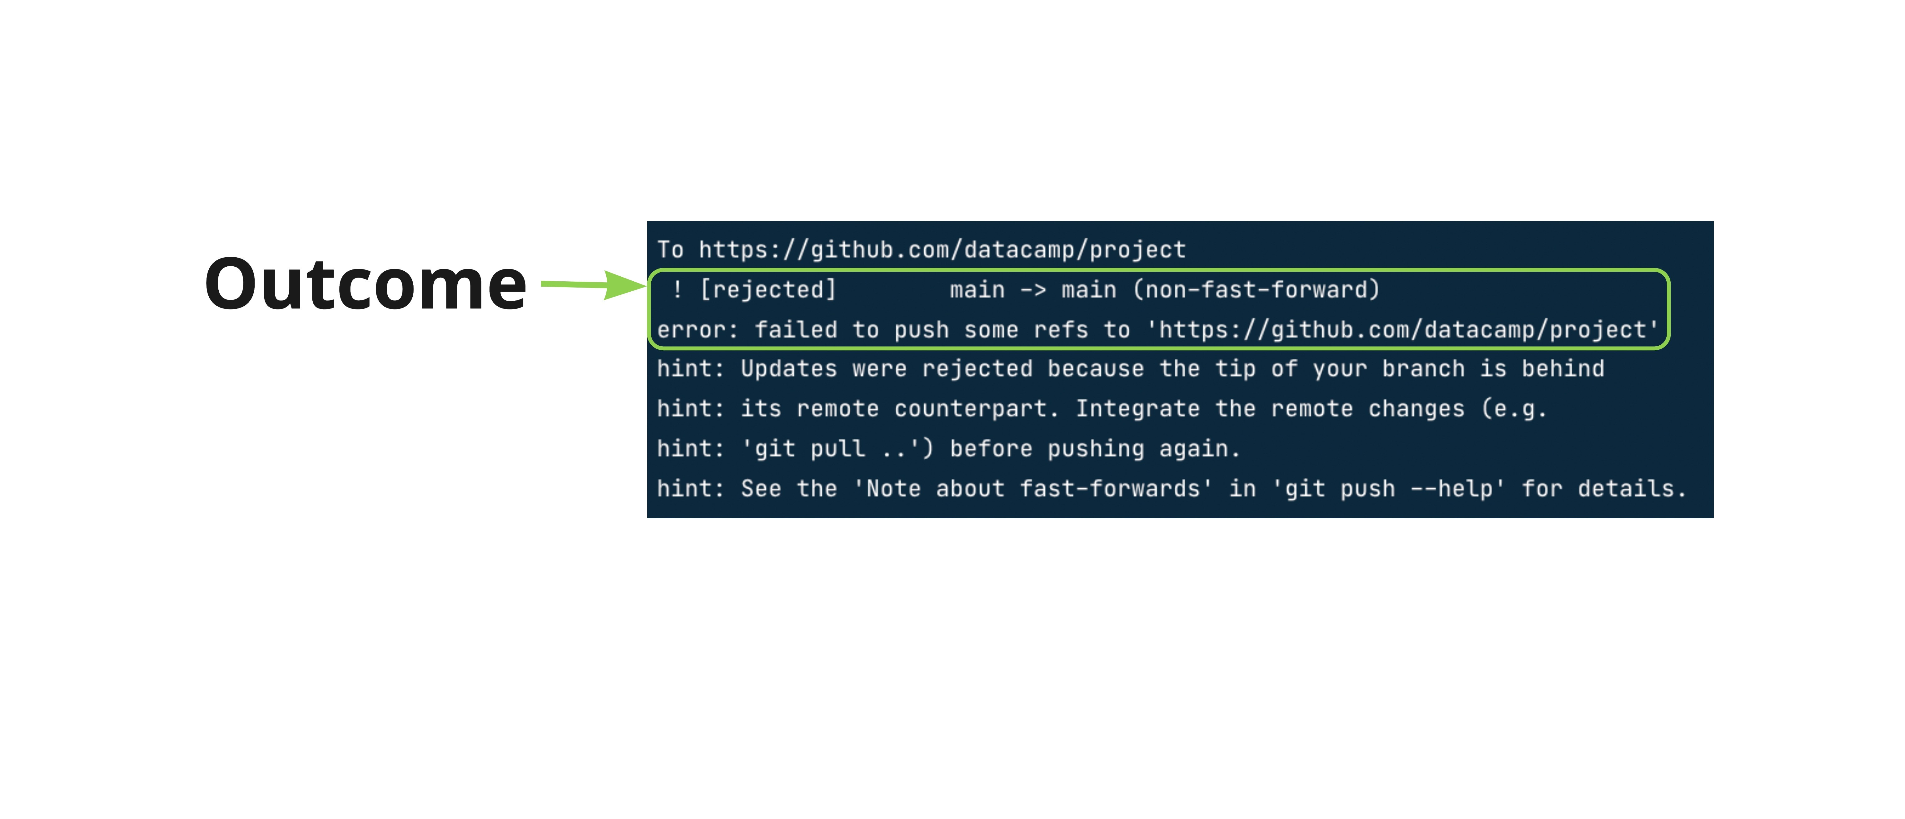

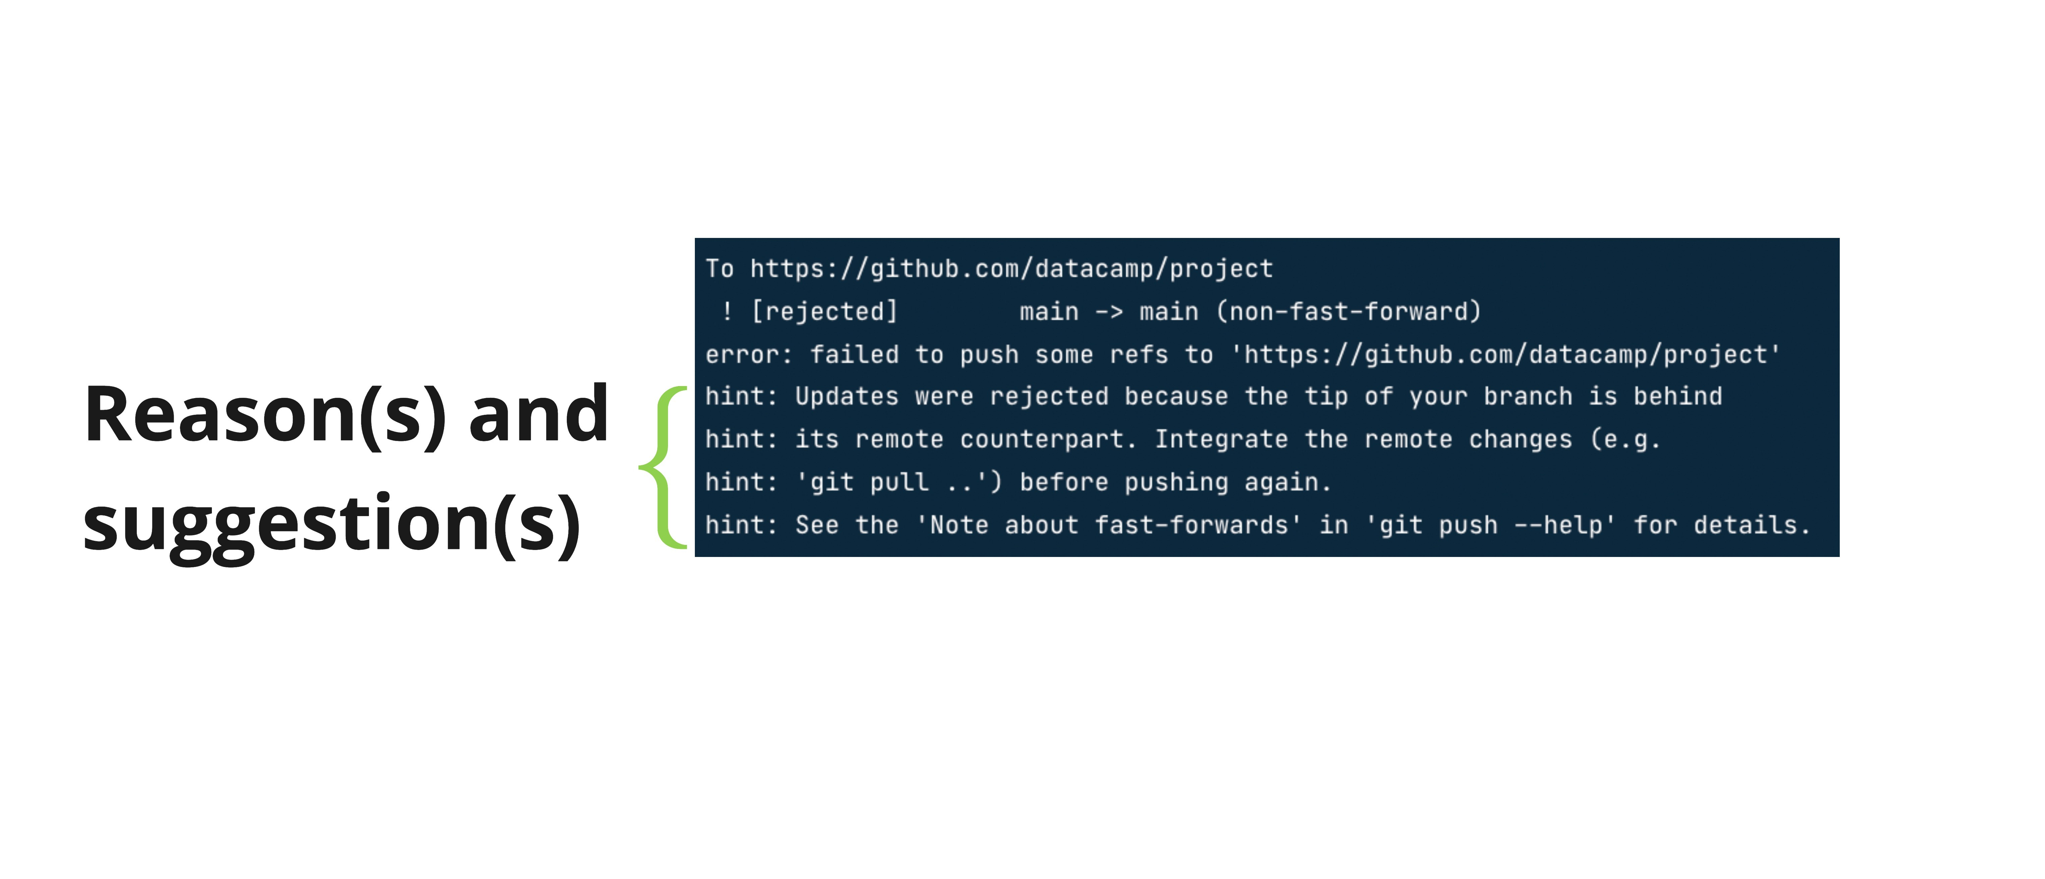

## Avoiding a conflict

Pull from the remote first

git pull origin main

## Pulling without editing

git pull --no-edit origin main

Not recommended, unless we are very confident in the history of our project!

## Pushing a new local branch

Working in hotfix branch locally hotfix does not exist in the remote

## Creating a new remote branch

Enumerating objects: 5, done.

Counting objects: 100% (5/5), done.

Delta compression using up to 8 threads

Compressing objects: 100% (2/2), done.

Writing objects: 100% (3/3), 349 bytes | 349.00 KiB/s, done.

Total 3 (delta 0), reused 0 (delta 0), pack-reused 0

remote:

remote: Create a pull request for 'hotfix' on GitHub by visiting:

remote: https://github.com/datacamp/project/pull/new/hotfix

remote:

To https://github.com/datacamp/project

* [new branch] hotfix -> hotfix

branch

'hotfix'

set

up

to

track

'origin/hotfix'

hotfix only exists locally

git push origin hotfix

**Let's practice!**

**INTERMEDIATE GIT**

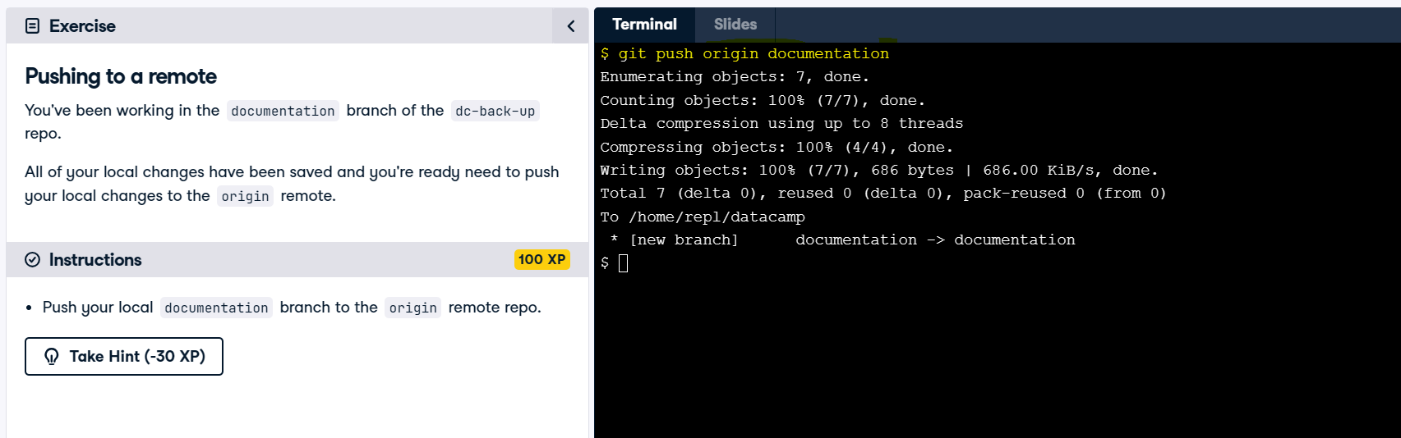

# Congratulations

## INTERMEDIATE GIT

## George Boorman

Curriculum Manager, DataCamp

## Branches

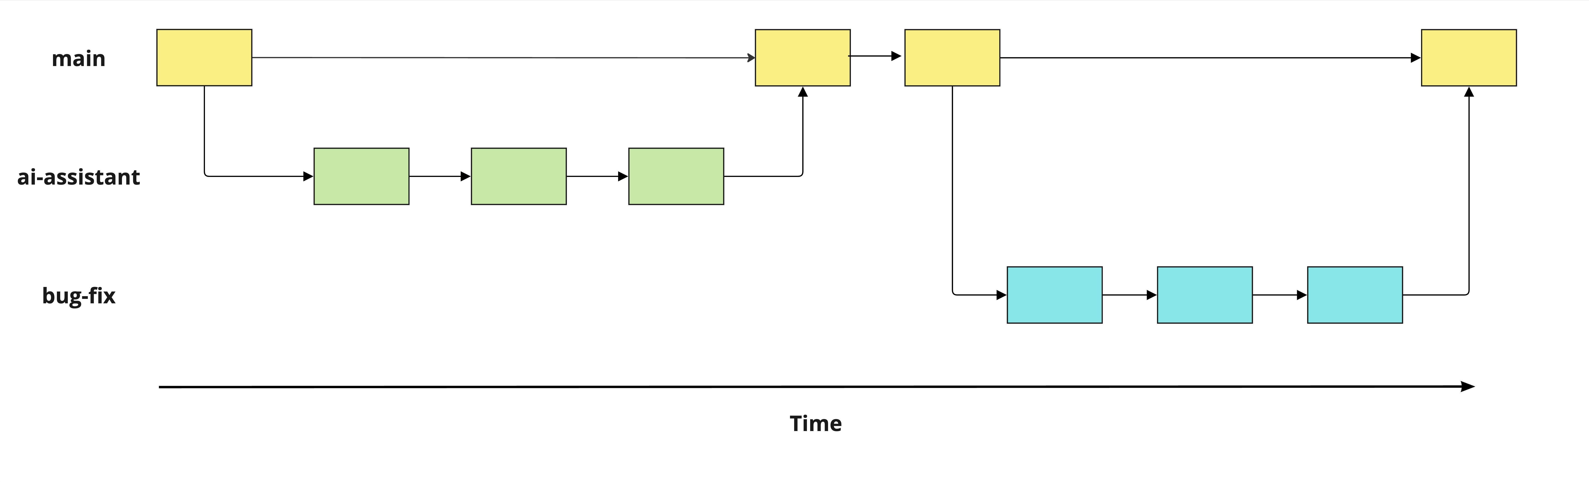

## Working with branches

See all branches

git branch

Compare two branches

git diff main hotfix

Switch to an existing branch

git switch hotfix

Rename a branch

git branch -m hotfix bugfix

Create and switch to a new branch

git switch -c hotfix

Delete a branch

git branch -d hotfix

## Merging branches

From

main

, to merge

ai-assistant

into

main

:

git merge ai-assistant

From another branch:

git merge source destination

git merge ai-assistant main

Handling merge conflicts

## Working with remotes

Clone a remote repo

git clone https://github.com/datacamp/project

Get information about all remotes

git remote -v

Add a new remote

git remote add george https://github.com/george_datacamp/repo

## Synchronizing local and remote repos

git fetch origin

git pull origin

git push origin documentation

**What next?**

[**GitHub Concepts**](https://www.datacamp.com/courses/github-concepts)

[**GitHub and Git Tutorial**](https://www.datacamp.com/learn/tutorials/github-and-git-tutorial-for-beginners)

Starting using Git for your software and data projects!

**Let's practice!**

**INTERMEDIATE GIT**